**SEMESTER TWO EXAMINATION - May 2017**

**MAIN**

|  |  |
| --- | --- |
| **FACULTY:** | Arts, Computing, Engineering and Sciences |
| **DEPARTMENT:** | Engineering and Maths |
| **MODULE TITLE:** | Introduction to Transport Phenomena |
| **MODULE LEADER:** | Lixin Cheng |
| **TIME ALLOWED:** | 2 hours (plus 10 minutes reading time) |

**___________________________________________________________________**

**SOLUTIONS**

**1.**

**(a)**



**(i)**

**[2 Marks]**

**(ii)**



**[2 Marks]**

**(iii)** The specific volume decreases with decreasing temperature from 50 °C to 10 °C.

**[1 Mark]**

**(b)**



**(i)**

**[1 Mark]**



**[2 Marks]**

**(ii)**



**[2 Marks]**

**(c)**

**(i)** Conduction, conveaction and thermal radiation **[3 Marks]**

**(ii)** For steady state conduction heat transfer, the temperature at a particular instant may vary with location in the medium but the temperature at a particular location does not vary with time.

**[2 Marks]**

**(d)**

**(i)** Volume change, *ΔV* = *m(vg-vf)*

*m* = 0.2 kg

From steam tables,

*vg* = 1.6941 m3.kg-1

**[1 mark]**

*vf* = 0.001043 m3.kg-1

**[1 mark]**

Thus,

*ΔV* = *0.2 (*1.6941*-*0.001043*)* m3

= **0.3386114 m3** or **338.6114 litres**

**[1 mark]**

**(ii)** Energy transferred, *ΔH* = *m.hfg*

From steam tables,

*hfg* = 2257.5kJ.kg-1

**[1 mark]**

Thus, *ΔH* = 0.2 x 2257.5 kJ

= **451.5 kJ**

**[1 mark]**

**(e)** Definition of critical point.

**[1 mark]**

1 kg of saturated water at 100 oC will take more energy to vapourise. This can be qualitatively seen from a T-s diagram or numerically verified from steam tables. As the temperature/pressure rises, there is smaller and smaller difference between saturated liquid and saturated vapour states.

**[3 marks]**

At the limiting value of *critical point*, this difference becomes **zero**.

**[1 mark]**

**2.**

**(a)**

**(i) Known: ρ = 1050 kg/m3, depth h = 40 m, patm = 101 kPa**

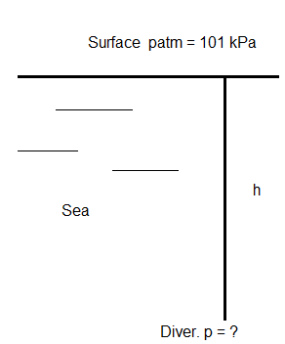**[1 mark]**



**[2 marks]**

**(ii)** If the depth from the water surface is decreased, the pressure exerted on the surface of the diver by water will decrease.

**[2 marks]**

**(b)** *Re = (ρDV)/μ*

= *(1.204×0.025×8.5)/1.82×10-5 = 14057.69* **[2 marks]**

*Re > 4000, Therefore, it is turbulent flow* **[1 mark]**

If the flow velocity is decreased, the friction loss will decrease.**[2 marks]**

**(c)**

**(i)** Known: V1 = 2.4 m/s, D1 = 30 mm, p1 = 80.5 kPa, D2 = 60 mm,

Z2 -Z1 = 2 m

Un known: V2 and p2

**[2 marks]**

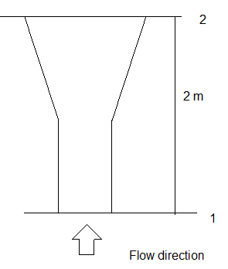

**[2 marks]**

First, make a sketch diagram and list the known condictions

Then, apply the euqation of continuity to find V2



**[2 marks]**

**[2 marks]**



**[2 marks]**

Finally, apply Bernoulli Equation:



**[2 marks]**

Solving for p2 = 63613.84 Pa = 63.615 kPa **[2 marks]**



**(ii)**

**[1 mark]**

**3.**

**(a)**

**(i)** Known: T1 = 250 °C, T2 = 150 °C, A = 10 m2 and k = 374 W/m2°C

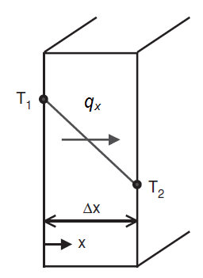

**[2 marks]**



**[2 marks]**

**[2 marks]**

**(ii)**



**[2 marks]**

**(iii)** If the thermal conductivity is decreased, the heat transfer rate will decrease.

**[2 marks]**

**(b)**

**(i)** Known:*T∞* = 30°C, *Tw* = 250°C, *h* = 25 W/m2°C

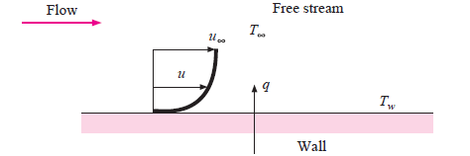**[2 marks]**



**[2 marks]**

**[2 marks]**

**(ii)**



**[2 marks]**

**(iii)**



**[2 marks]**

**(c)**

**(i)** Known:*Tr* = 850°C



**[2 marks]**

**[2 marks]**

**(ii)** If decreasing the temperature, the radiant energy rate per unit square meter will decrease.

**[1 mark]**

**4.** Using steam tables, determine if the fluid is compressed (sub-cooled), saturated liquid, vapour-liquid mixture, saturated vapour or superheated vapour. Then, use interpolation to get the missing values from the table.

**[2 marks for each part]**

The completed table is:

|  |  |  |  |  |  |
| --- | --- | --- | --- | --- | --- |
|  | T,  °C | P,  kPa | *u*,  kJ/kg | x  - | Phase description |
| A | 425.19 | 1000 | 3000 | - | Superheated vap |
| B | 175.35 | 900 | 741.55 | 0.0 | Saturated liq |
| C | 130 | 270.28 | 1600 | 0.529 | Vap-liq mix |
| D | 123.97 | 225 | 1728.09 | 0.6 | Vap-liq mix |
| E | 70 | 500 | 293.04 | - | Compressed/ subcooled liq |

**[5 marks for each part]**

**[TOTAL 25 marks]**